# ASSIGNMENT 1

# Hangman Game

**S220 PRT5882: SOFTWARE ENGINEERING: PROCESSING AND TOOLS**

**Name: Imrandeep kour**

**ST ID: S334861**

**Game Requirements:**

1. One word will be generated randomly
2. Player will be presented with a number of blank spaces representing the missing letters the player needs to find.
3. If the player’s chosen letter exists in the answer, then all places in the answer where that letter appear will be revealed.
4. Every time the player guesses a letter wrong, the player’s life will be deducted.
5. The player must find the missing word before the player’s life becomes zero.

**System Requirements:**

1. Python Installation (Python v3.5)
2. Python Editor (Notepad++)

**Implementation Steps:**

Step-1: Retrieve a word list (word.py)

Step-2: Create new python code for Hangman (assignment_hangman.py)

Step-3: Import random words from "word.py" file.

Step-4: Define random word in command prompt with random function and return in upper case.

Step-5: Define hangman function.

Step-6: Put numeric life instead of image, here declared "6" lives for each game.

Step-7: Described if-else conditions for right and wrong guess. For each wrong guess, deduct one life.

Step-8: On successful guess echo "YAY! You guessed the word".

Step-9: If "life=0", show game over and quit.

**Refractor Code Smell:**

While testing the code on python 2.7 environment, code is throwing some error:

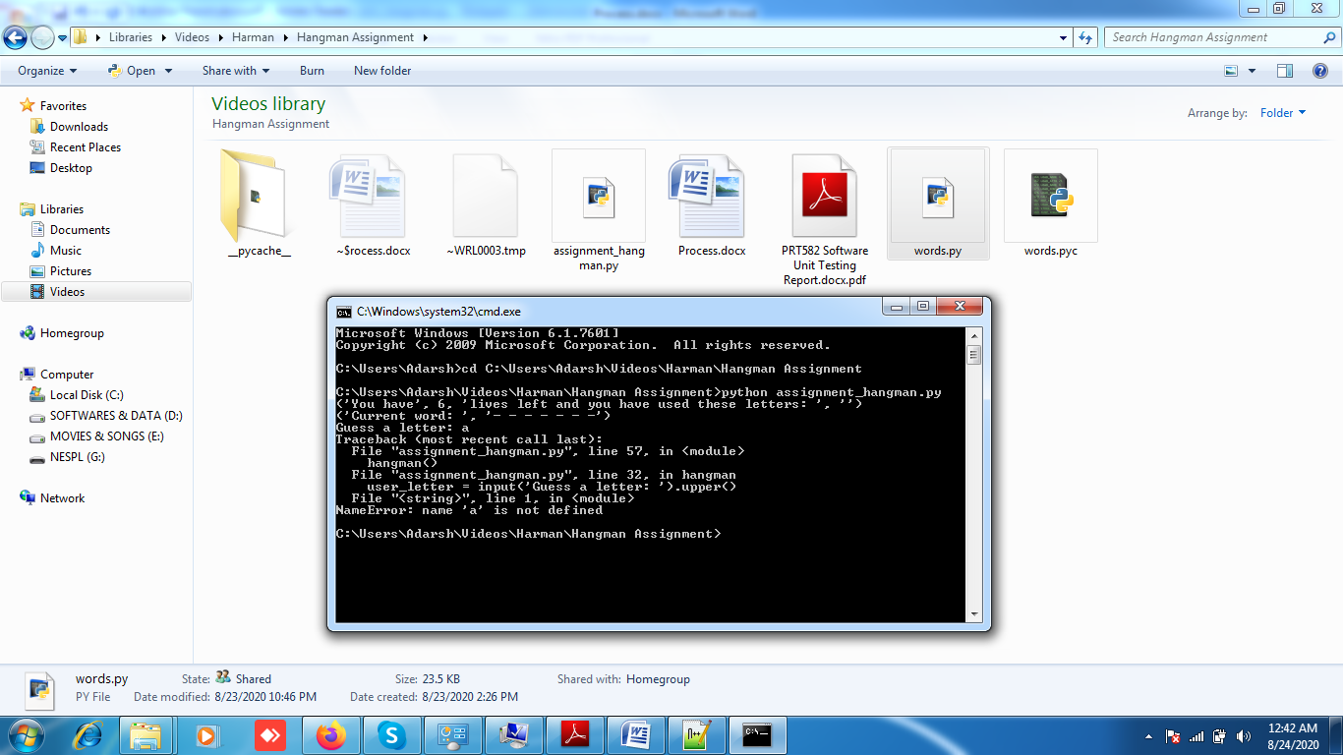

Error because of the library used for hangman() method is unable to parse the upper case letter and string matching.

Resolution of this error during code refracting is declared as it need Python3 environment to fulfill the library functions requirements. After installing Python 3.5 and run the code, it is working well without any error. 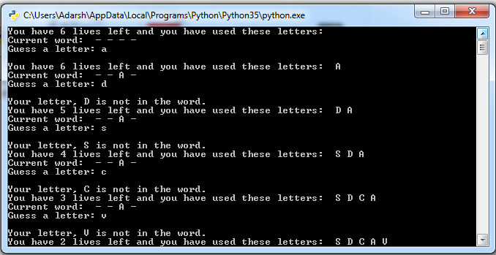

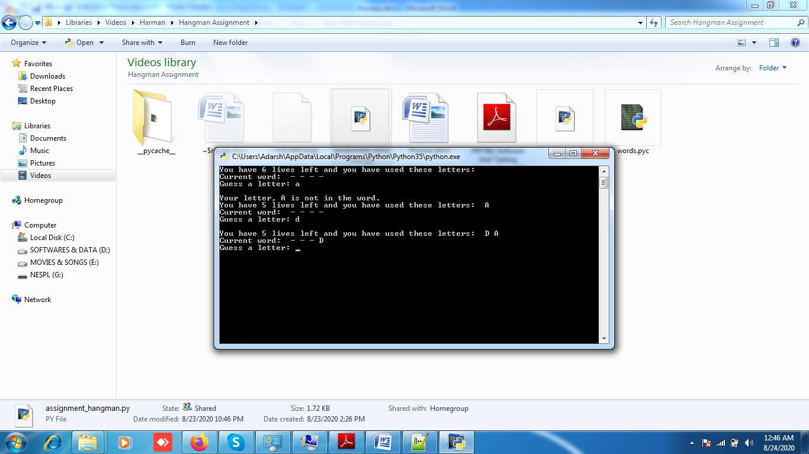

NEXT STEP :



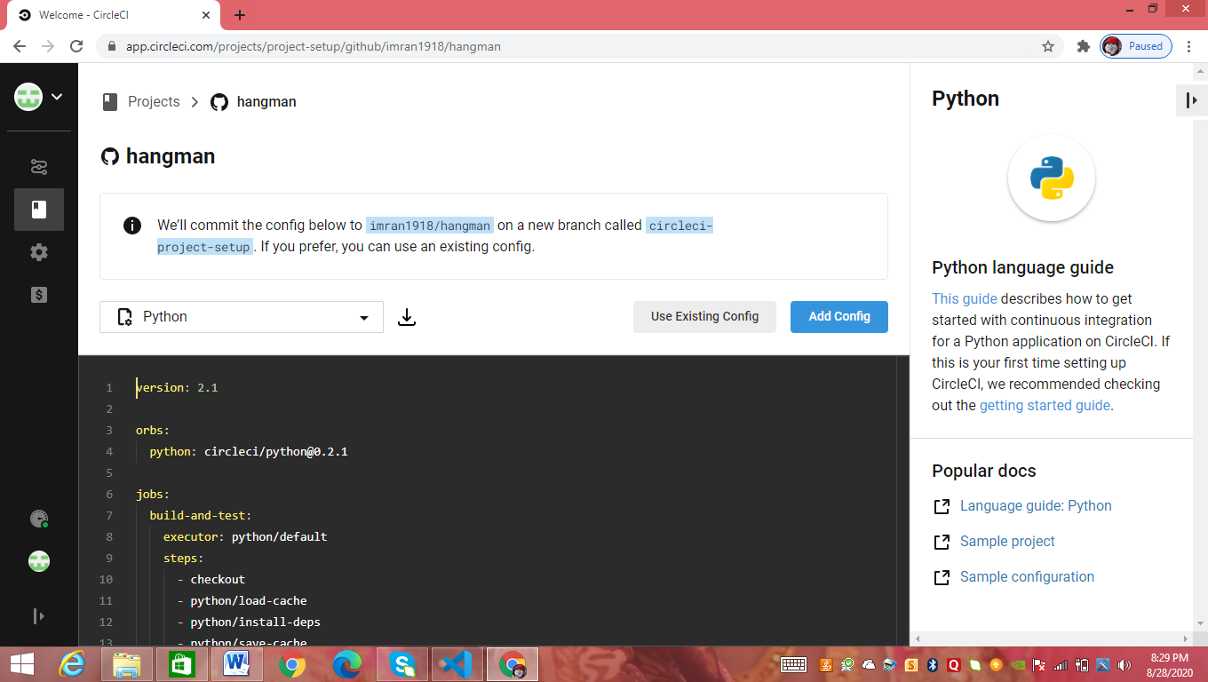

* After that I upload my project in Github and link is <https://github.com/imran1918/hangman>